Highlights of the Maine Department of Health and Human Services Biennial Budget Proposal
for FY 2022 and FY 2023

Governor Mills’ proposed budget for the FY22-23 biennium focuses on combatting the COVID-19 pandemic by continuing to rebuild the State’s public health infrastructure and protecting essential health care, education, and life-saving services. This proposal, which is balanced as required by law and addresses the revenue shortfall caused by the pandemic, achieves these goals while also preserving sound financial footing for the State, holding the line on tax rates and new programs, and bringing the Budget Stabilization Fund to a record-high savings.

As the largest department in State government, the Department of Health and Human Services (DHHS or Department) is a central component of the proposal, providing health care and social services to approximately one-third of the state’s population, including children, families, and older Mainers, as well as individuals with disabilities, mental health, and substance use disorders.

Overall Budget

Governor Mills’ budget proposal for the FY22-23 biennium continues policy efforts initiated at the outset of her Administration – rebuilding critical parts of State government, such as services for Maine’s most vulnerable residents and public health infrastructure, and expanding health care to better serve and protect Maine families.

Considering the acute and unprecedented demand on Maine’s health and human services infrastructure, these investments continue to be timely, important and responsible. Amid the difficult fiscal environment of the COVID-19 pandemic, this has been achieved by balancing any increases in spending with reductions elsewhere, while avoiding layoffs and ensuring vital services.

For DHHS, the Governor is proposing $2.81 billion in General Fund appropriations for FY22-23, an increase of 2.4 percent over the current biennium. When compared to existing baseline commitments in the currently enacted budget, however, this amount is, on net, down from $2.84 billion, made possible because of savings initiatives.

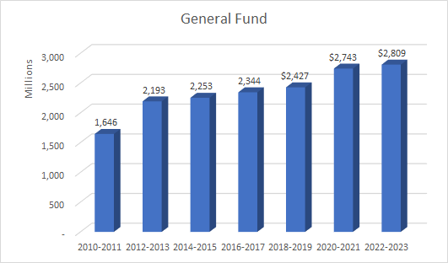

Major Initiatives
The pandemic has further highlighted the need to reinvest in and rebuild Maine’s public health infrastructure.
- At the Maine CDC, this budget proposes initiatives to expand capacity at the Health and Environmental Testing Laboratory, Health Inspection Program, and Maine Immunization Program, among others.
To further fulfill the State’s commitment to vulnerable Maine people, the proposed budget builds upon efforts approved in the last biennial budget by:
- Increasing the number of adults with intellectual and developmental disabilities and Autism served through the Section 29 program;
- Continuing to fill gaps in the mental health system and tackling opioid and other substance use disorders;
- Making further investments to improve the child welfare system; and
- Providing increased payments to Maine’s nursing facilities and other residential services providers.
Additionally, the proposed budget aims to protect health care coverage for Maine people by:
- Dedicating $25.5 million to the Medicaid Stabilization Fund for potential MaineCare expenses; and
Finally, the budget adds 49 new DHHS positions, or 1.4 percent of the currently approved headcount at the Department, and continues 78 existing limited period positions.
Savings and efficiencies
As required by the current fiscal climate, the Governor has proposed offsetting these increases through various savings and reductions, seeking to minimize programmatic impact and to maintain health care coverage and preserve services for those who need them.
Savings are achieved through maximizing non-General Fund resources, such as enhanced Federal Medical Assistance Percentage (FMAP) reimbursement made possible by Medicaid expansion. The higher FMAP rate tied to the declared Public Health Emergency also yielded savings.
The Governor has proposed rebalancing funding between General Fund and Other Special Revenue Funds, taking advantage of increases in the rebates received for eligible pharmaceuticals in the state’s Medicaid program.
The Department identified program efficiencies and contract savings. Additionally, DHHS has aligned compliance requirements to cost savings measures and pursued parity across rates structures to realize savings.

Background

The major policy initiatives noted above include the following:

Reinvesting in public health:

- $5 million for Maine CDC for COVID-19 testing, vaccines, and support services for people who need to stay in isolation and quarantine (supplemental);
- $3 million for the Maine CDC for additional capacity at the Health and Environmental Testing Lab (HETL), the Health Inspection Program (HIP), the Maine Immunization Program, and the Public Health Emergency Preparedness Program; and
- $6 million to ensure the continued effectiveness and efficiency of the Maine CDC’s Health and Environmental Testing Lab and Health Inspection Program.

Further strengthening services for adults with intellectual and developmental disabilities:
- $6 million to fund Section 29 services for adults with developmental disabilities in their homes and communities by an additional 30 slots per month.

Providing $45 million for MaineCare rate increases:

- $20 million for Section 21 and 29 rate increases to support adults with intellectual and developmental disabilities;
- $11 million for nursing facility cost-of-living adjustments and rebasing increases;
- $9 million for residential facilities that serve children to meet the Qualified Residential Treatment Provider status; and
- $5 million for other rate increases for Residential Care for older Mainers, Adult Family Care Homes, Federally Qualified Health Centers, and Rural Health Clinics

Bolstering mental health and substance use disorder services:

- $5.5 million for community mental health and substance use disorder services, including funds for crisis services in Cumberland County, MaineCare reimbursement for intensive outpatient treatment; and a Justice and Health Team to reduce the strain on emergency departments, jails, state psychiatric facilities, and the criminal justice system with the goal of providing appropriate care for people with acute mental health issues, substance use disorders, and/or intellectual/developmental disabilities in the most appropriate setting.

- $2 million (from Fund for a Healthy Maine) to promote the OPTIONS (Overdose Prevention Through Intensive Outreach, Naloxone and Safety) Initiative to dispatch mobile response teams to communities with high rates of drug overdoses in every Maine county.

Continuing improvements in child welfare:
- 15 child welfare positions focused on preventing abuse and neglect;
- $6.8 million to finish modernizing the core child welfare information technology system (supplemental and biennial).

Dedicating funding to the Medicaid Stabilization Fund:

- $25.5 million to protect against unexpected MaineCare expenses, such as potential higher enrollment and costs due to persistent unemployment, potential federal restrictions on a decades-old funding source, and potential implementation of recommendations from the MaineCare comprehensive rate system evaluation.

DHHS is comprised of nine offices and divisions that oversee and administer critical programs and services for the state of Maine. The General Fund Proposed Appropriated Budgets for these offices in FY 2022-23 is as follows:

- The Office of MaineCare Services, in collaboration with other offices, provides health care coverage to over 360,000 people – and counting – as the expansion of the MaineCare program continues. It works closely with the Office for Family Independence (OFI), which complements health benefits with food supplemental payments, work supports, and financial assistance for low-income families. Both offices partner closely with the federal government to provide benefits and services. The General Fund appropriation for the Office of MaineCare Services is almost $1.9 billion for the biennium, while the General Fund appropriation for OFI is $158 million for the same period.

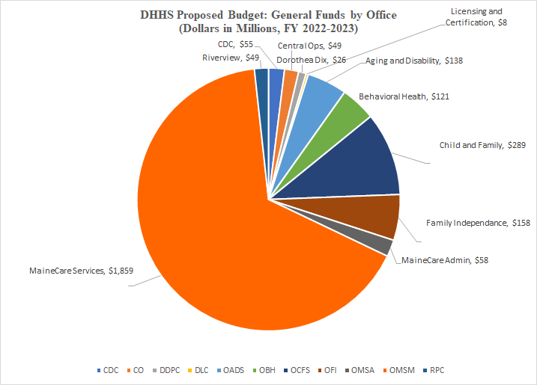

- Both the Office of Aging and Disability Services (OADS) and the Office of Behavioral Health (OBH) work closely with OMS. The General Fund appropriation is about $138 million for OADS and $121 million for OBH. OBH provides prevention, community-based, and residential services, complementing the work of our two State-run psychiatric hospitals, Riverview and Dorothea Dix, whose General Fund appropriations are $49 million and $26 million respectively.

- Prevention is the core mission of the Maine Center for Disease Control and Prevention (CDC), which has the additional goal of limiting the spread of acute and chronic illness. While the General Fund Appropriation is $55 million, that represents less than 20 percent of the total CDC budget given other sources of funding. It, along with the Division of Licensing and Certification (General Fund appropriation of $8 million), enforces standards for safety, quality, and public health.

- The Office of Child and Family Services oversees programs for early childhood development, children’s behavioral health services, and critical child protective services. The General Fund appropriation for 2022-2023 is $289 million.

