Perkins CLNA

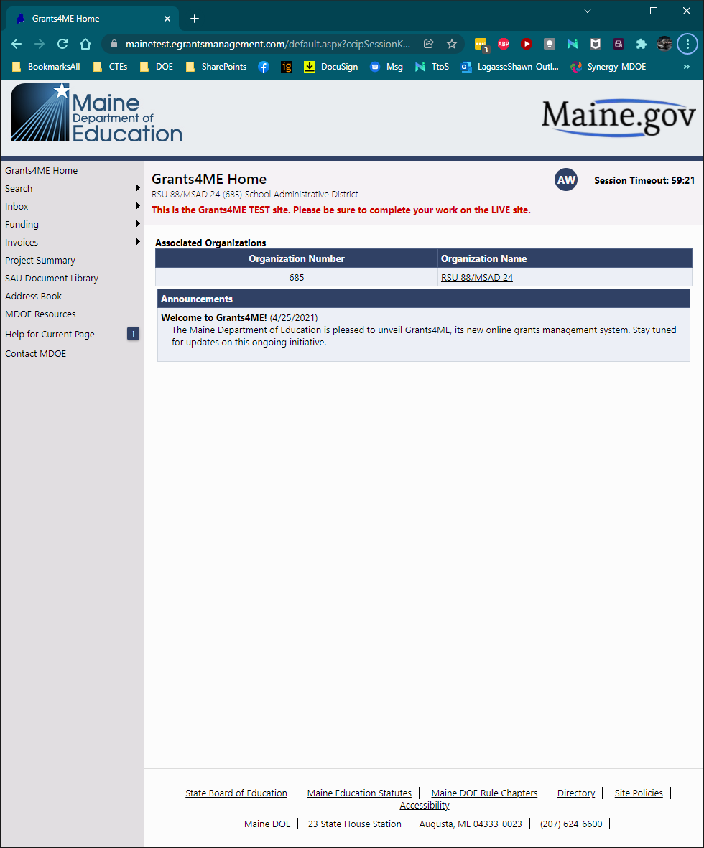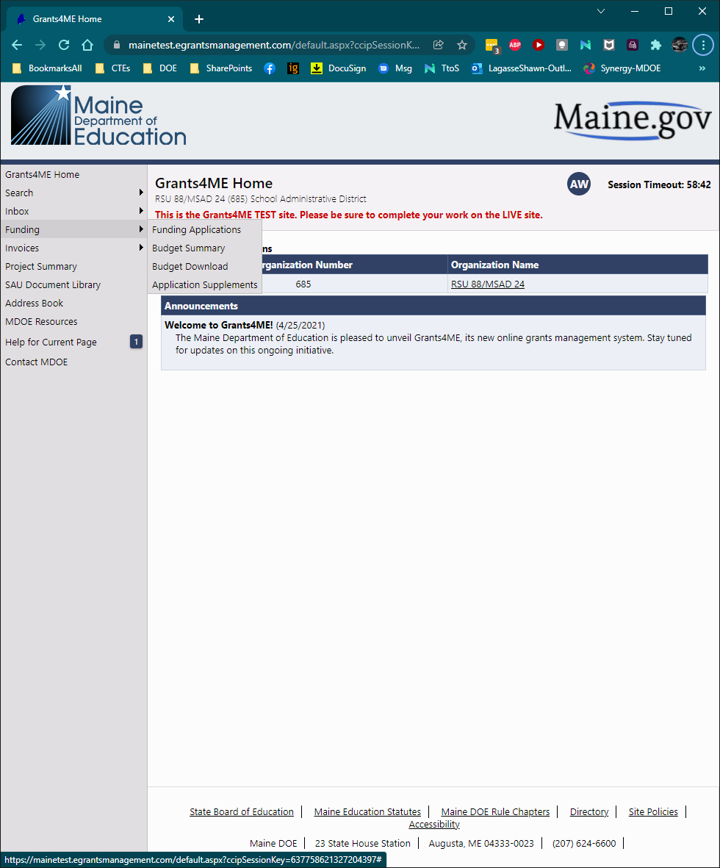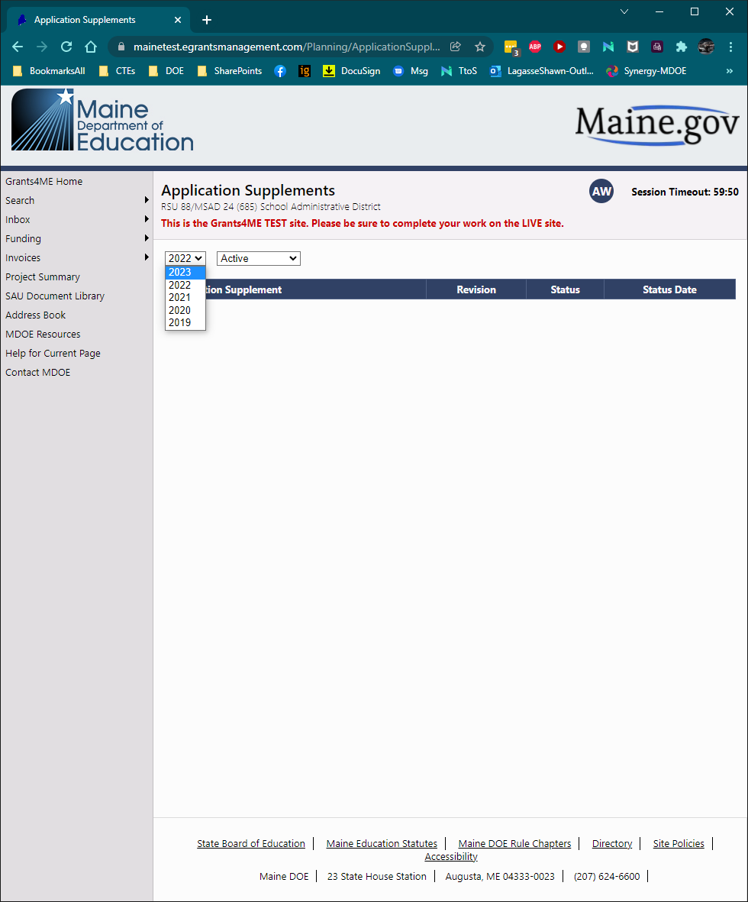

CLICK

CLICK

CLICK

CLICK

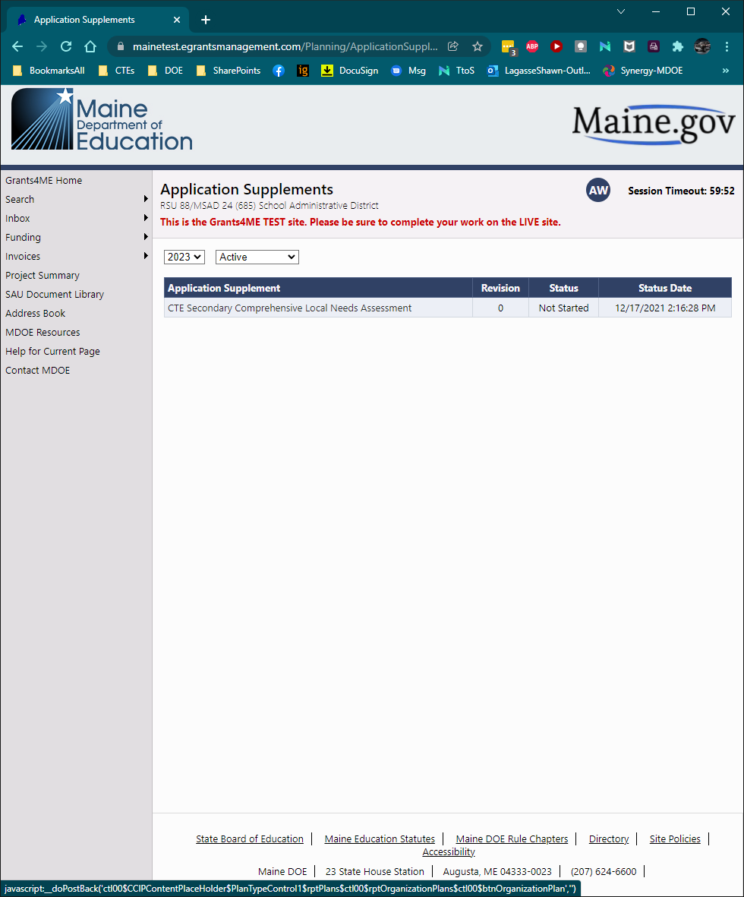

CLICK

G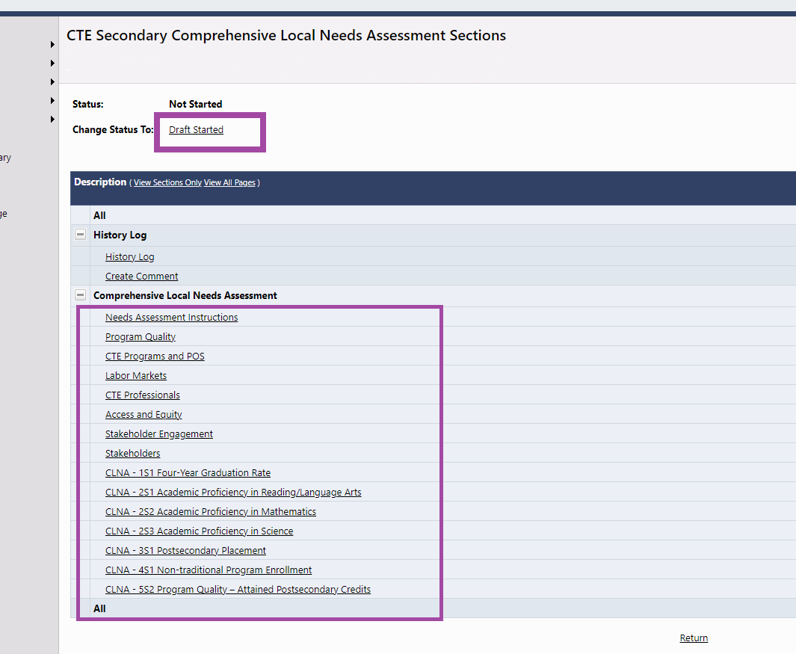

These are the links to all of the sections of the CLNA. Filling out the CLNA follows the same process as the Perkins Application.

Change Status To Draft Started

G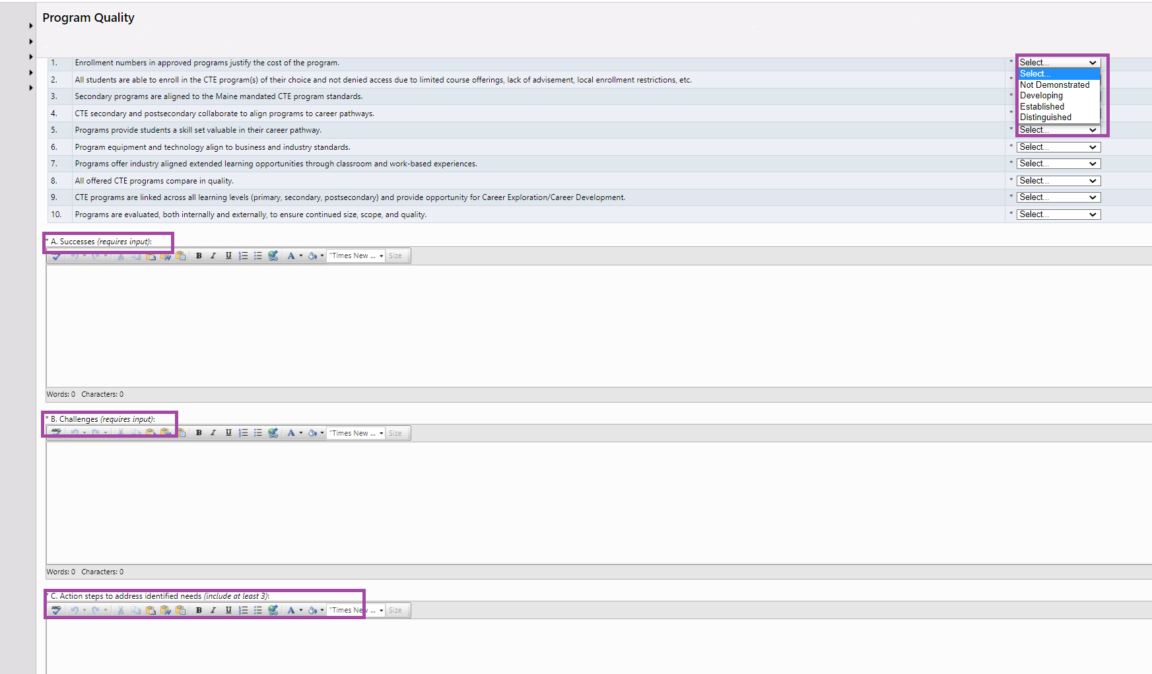

Enter the action steps you will take over the next two years to address challenges and/or improve.

Enter the challenges you have had during the past two years.

Enter the successes you have achieved during the past two years.

For each section you must self-evaluate using the dropdown boxes. You must select a response for each question.

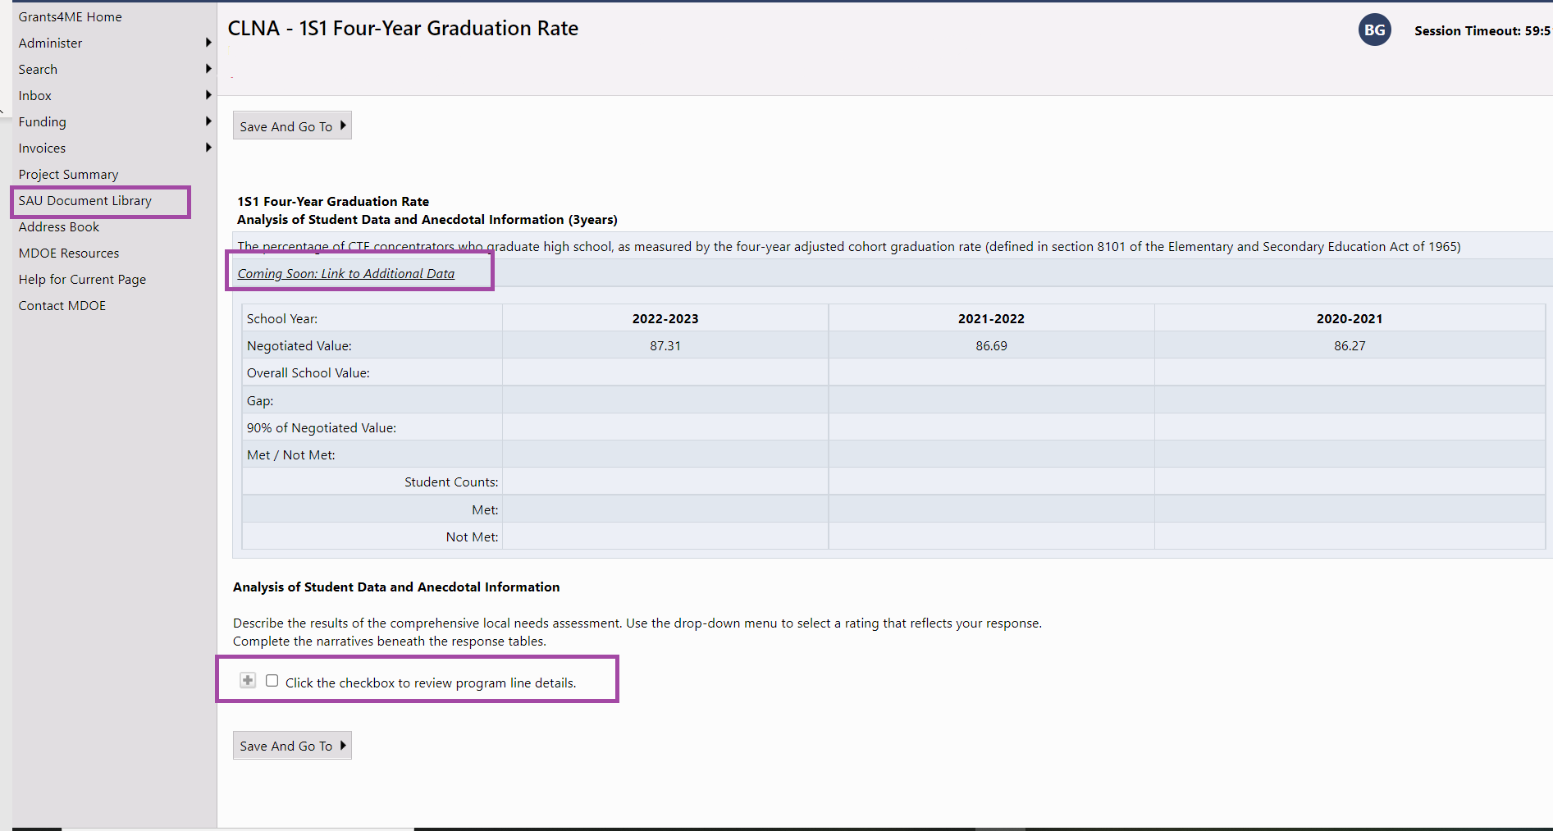

This link takes you to your Document Library. (See further down in this document for instructions.)

By clicking this box you are indicating that you have reviewed your data document. Once you click the box it will open the questions to be completed this section. This process is used for all 6 performance measures.

This link currently is not active. You will navigate to the data through the SAU Document Library. (Directions provided further down in this document.)

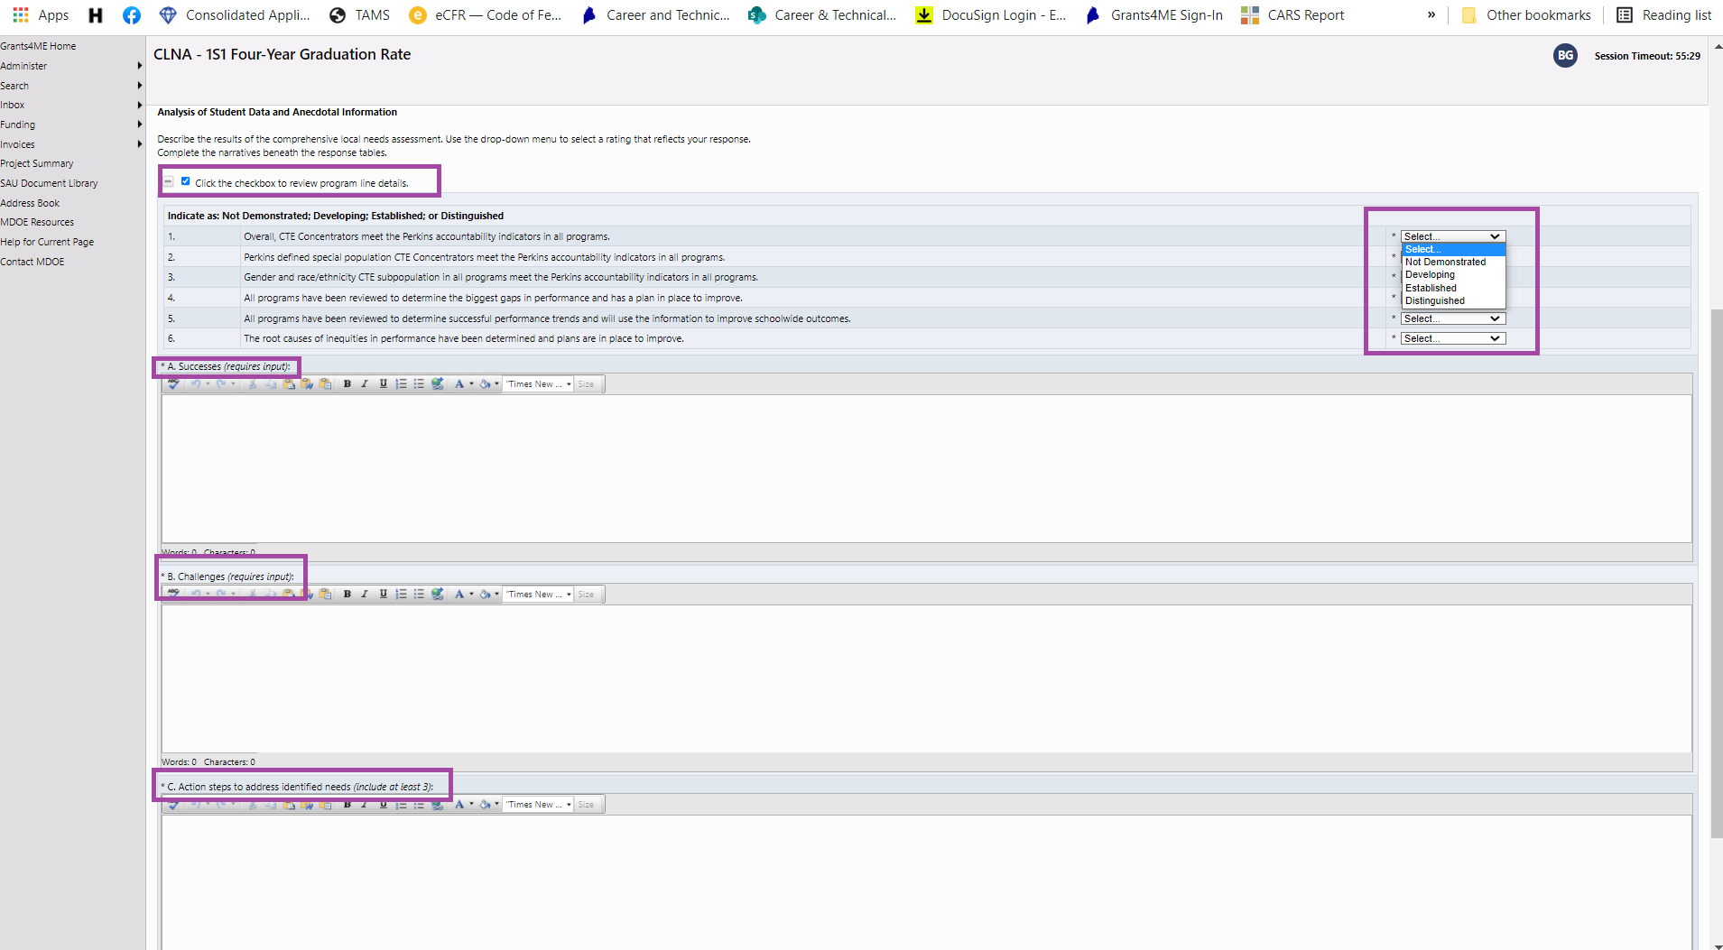

Enter the action steps you will take over the next two years to address challenges and/or improve.

Enter the challenges you have had during the past two years.

Enter the successes you have achieved during the past two years.

For each section you must self-evaluate using the dropdown boxes. You must select a response for each question.

This shows checkbox checked so you can see the section questions.

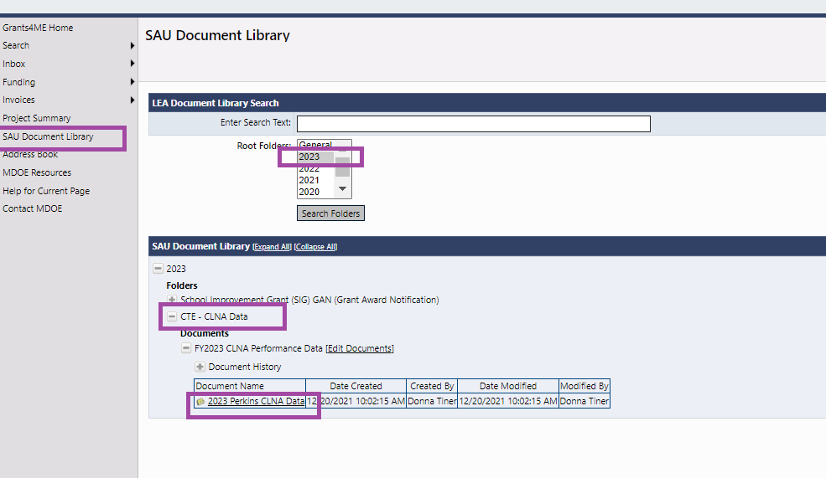

This link downloads your performance data spreadsheet that is the same format as the first CLNA.

Select CTE CLNA Data

Select 2023 from the dropdown and then click Search Folders.

Click on Document Library.

NOTE – Due to COVID data collection has been slowed. As many measures do not have data sets you will need to use anecdotal data to complete the performance sections of your CLNA.