Synergy - CTE Credit Bearing Upload Guide

- This upload will enter CTE program data into Synergy on the Student CTE screen.
- Complete the CTE upload after the Student Enrollment upload has been successfully uploaded – students must have a primary enrollment and a concurrent enrollment at a CTE school prior to completing this upload.

Contents
File Preparation: 1
File Upload: 2
Results: 5

File Preparation:

Option 1: use your local Student Information System such as Infinite Campus, Power School or Web2School to export a file. You will need to work with your local SIS for assistance in downloading the file from their system.

Option 2: Fill out the CTE sample file which can be downloaded from here: https://www.maine.gov/doe/data/student/Synergy_upload.html
(Note: the sample file has example students that you will need to delete.)

The upload file needs to be in either CSV or TXT format. You cannot upload an XLSX (excel) file. The sample file can be edited in excel but must be saved as a CSV.

The CTE Credit Bearing upload file must have the 9 required columns. The CTE Credit Bearing Upload requirements document lists the columns and the order they must be in. The CTE Upload requirements document can be downloaded here:
https://www.maine.gov/doe/data/student/Synergy_upload.html

File Upload:

- In the top right, click the school year or school/district name and the Change Focus box appears.
- Select the following in the Change Focus box and click Save:
Year: Select the current school year (the example picture shows 2020-2021)
Organization: Choose your district (the example picture shows Rock Star Public Schools) Show Students: Show Active and Inactive
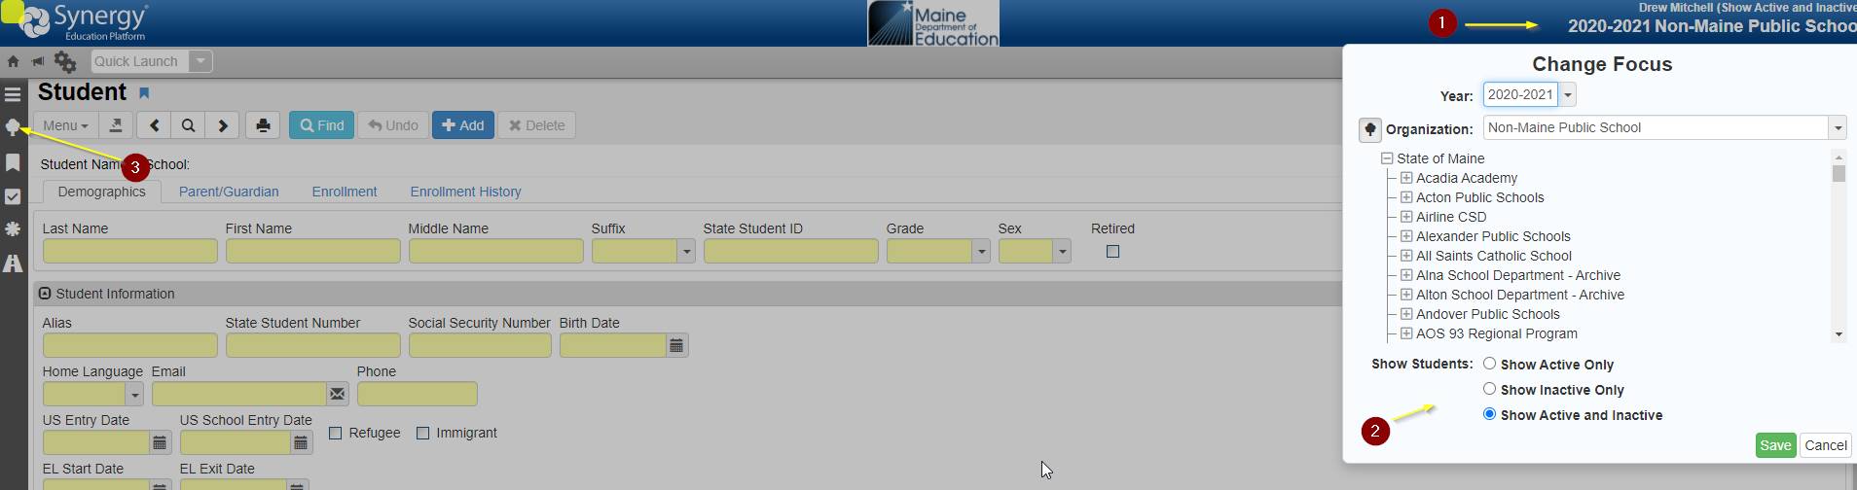

- Click the arrow next to Synergy SIS to expand the section.
  - Click the arrow next to ME to expand the section.
  - Click State Reporting Status.
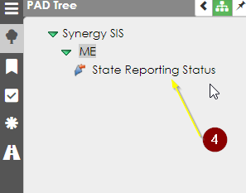
- In the State Reporting Status page, hover over the Menu drop down. Click Upload File:
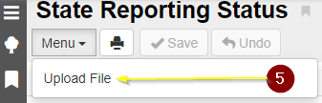

- In the Upload File box, click the File Type drop down. Select CTE.
- Click the Attach File button.
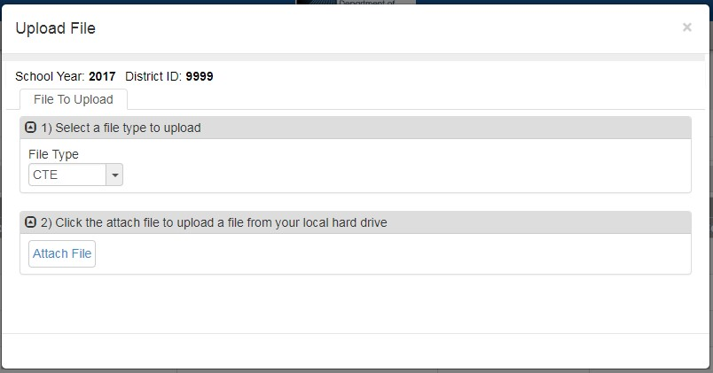
6

7

- In the File Upload box, click Choose File.
- Locate your file and then click the Upload button.
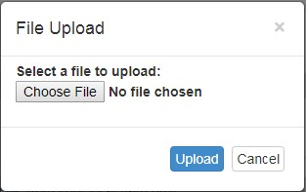

8

9

- On the State Reporting Status page, click the refresh button in the top right.
- The upload is complete when numbers appear in the Row Count, Success Count and Error columns. (You may need to click the refresh button multiple times).
- Click on the Result Log to the right and download the file.

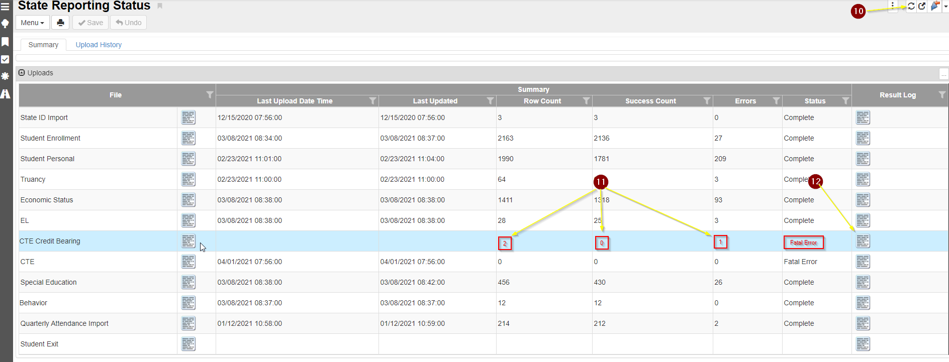

Results:

If all CTE Credit Bearing data was successfully upload you will receive this message in the result file:
CTE Import Error Log
All Records completed successfully

If not all CTE data was uploaded, the result log will have 5 columns:

Row Number: corresponds to the row in the upload file that had the error.
SAU ID: is the SAU ID found in the upload file
School ID: the ID used in your local SIS
State Student Number: The student’s State ID
Error: a message about why the data was not uploaded

The following Error messages indicate there was an issue processing the student’s data:

ERROR | RESOLUTION
Secondary enrollment not found at "Capital Area Technical Center" | There has not been a concurrent enrollment created for the student. The Student Enrollment upload must be completed before the CTE upload.
Unable to resolve CTE Code "43" | The CTE code in the upload file is incorrect. CTE codes can be found here:  https://www.maine.gov/doe/data/student/Synergy_up load.html

