ESEA Demographics Report

Report Details

Reporting Timeframe: Open Date: 5/15 Due Date: 6/15

Who should report: RSUs, CSDs, MSADs, Municipal school units, Maine Indian Education, Charter schools, State Operated schools, and Private schools that accept publicly funded students.

Description: The ESEA Demographics Report is an aggregation of students enrolled on 05/27 for participation in state assessments during the current assessment administration. This report includes student demographic categories for assessment and accountability purposes.
Completion Instructions:

To access this report, you will log into NEO. (An active NEO account AND Student Data permission are required).

Then go to Student Data, then Student Reports, you will see these two reports.
- Certification Report will load the district aggregate totals and allow the Superintendent to certify the data.
- Detail Report will load all district students that have been entered to Synergy to show their expected tests and demographics.
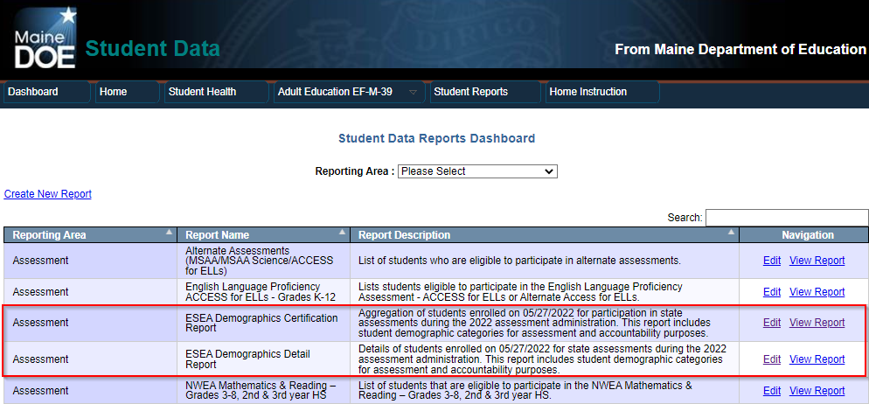

Click on ‘View Report’ for ‘The ESEA Demographics Certification Report’. Then select your district under the Reporting Organization dropdown which will load your district data:

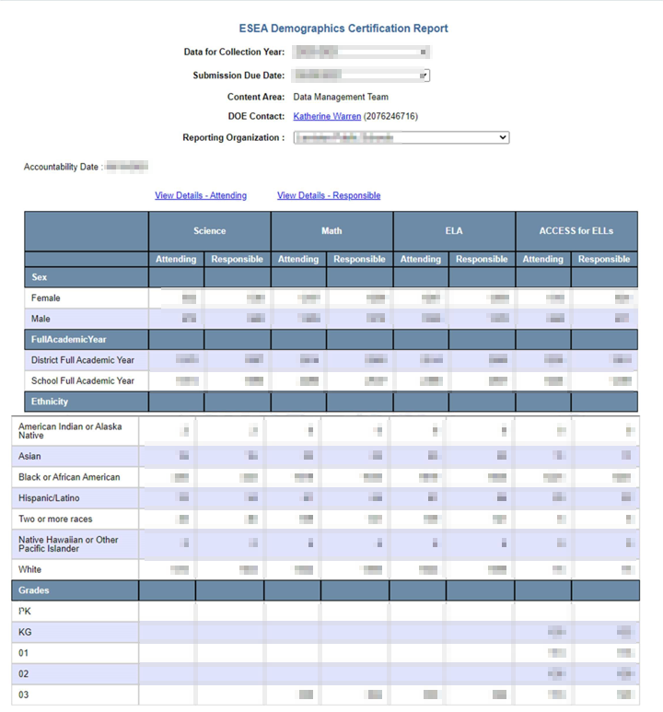
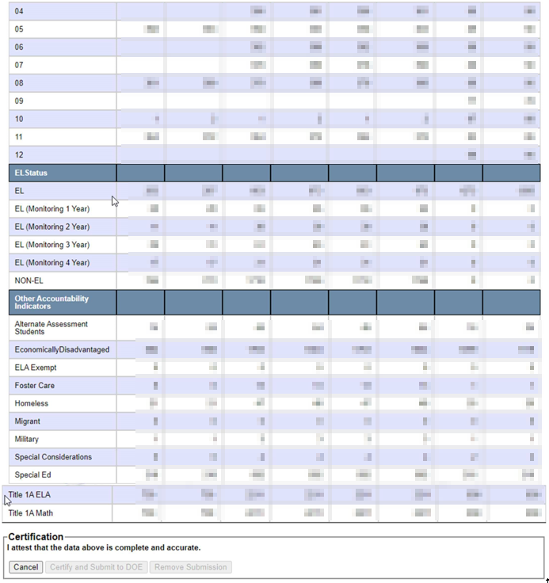

The report is segmented into 4 columns, 1 for each type of assessment: Science, Math, ELA, & ACCESS for ELLs. The rows indicate the total counts of students identified in Synergy for that demographic group.

Important things to note:

- The Report only tracks students enrolled with the SAU on May 27th. If they exit the district prior to this date, they will not be on the report.

- The total demographic counts on the certification page only include your District Full Academic Year students. Full Academic Year means that they were enrolled with your district continuously from October 1st to May 27th.

- Only the Superintendent will be able to click the ‘Certify and Submit to DOE’ button.

Detail Report Instructions:

Using the ESEA Demographic Detail Report link on the Student Report dashboard will load the individual student-level data for your district:

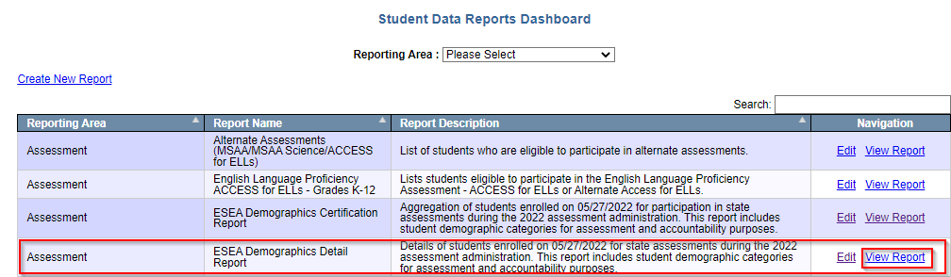

Select your district and/or school you wish to view, and click View Report to load the data:

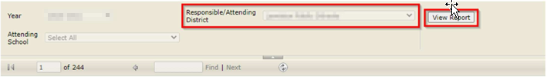
The report will display all students in the district, regardless if they are in a testing grade or not. You may use the filters of search box to locates students, or you may use the disk icon in the navigation bar to download the data as a spreadsheet:

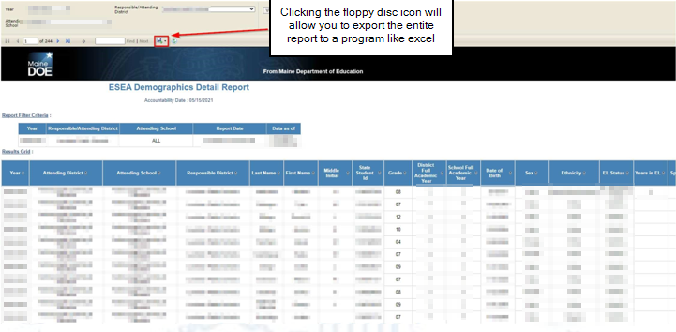

If changes are needed, they can be done directly in Synergy and this report will update automatically within an hour and a half. Once everything looks correct, the Superintendent can click on ‘Submit/Certify’.

Contact Information
MEDMS Helpdesk:
Email: medms.helpdesk@maine.gov Phone: (207) 624-6896

