Creating a Long-Term Sub & how do I return the original teacher?
In order to add a “Substitute Teacher - Long Term” assignment, you must designate a current active Classroom Teacher and set the Classroom Teacher to be “On Leave”. When the Classroom Teacher returns from leave, the assignment is set to “Return from Leave” and the application will automatically end the assignment of the Long Term Sub.
Create the assignment for the Long-Term sub similar to the following:
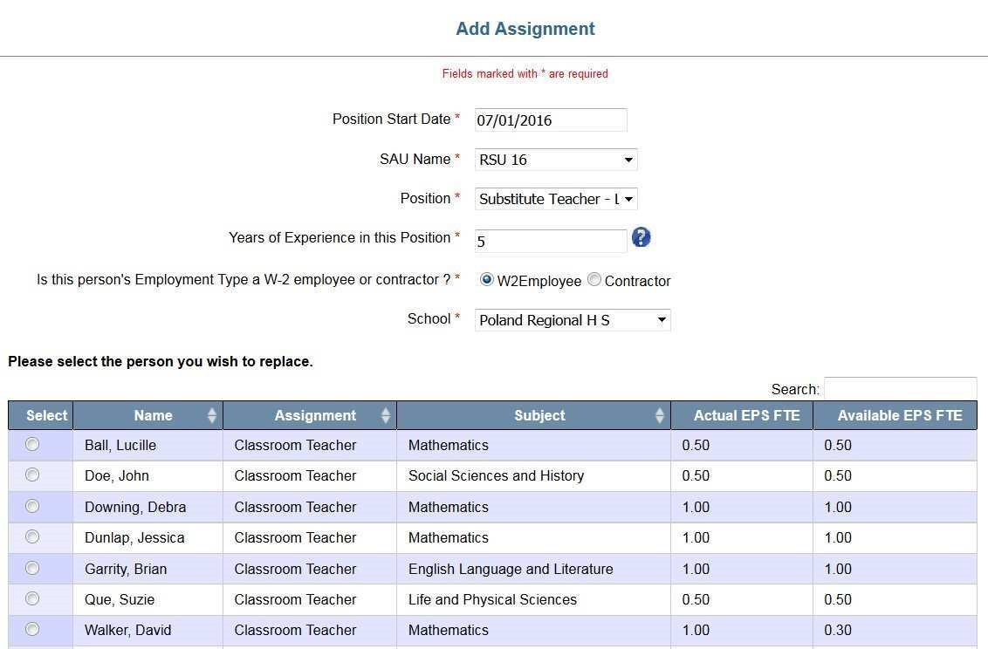

Note that once you select the school, additional information appears displaying all current Classroom Teachers in the school which you selected. You must select a name from this list in order to continue. This one-to-one relationship will continue until the teacher that went on leave returns. It is permissible to create more than one Long Term Sub position for each Classroom Teacher position going on a Leave of Absence as long as the cumulative totals of the EPS FTE for the Long-Term subs do not exceed the EPS FTE of the Classroom Teacher. The remainder of the assignment must be completed, and the record submitted. By entering the Long-Term Substitute before the Classroom Teacher, it will automatically put the Classroom Teacher on leave by saving the Long-Term Sub assignment.
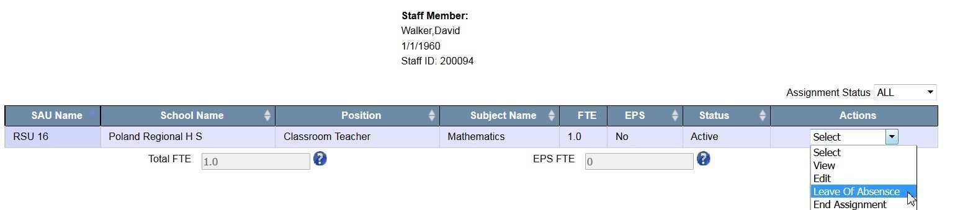
You may also put a person on leave without actually replacing them with a Long-Term Substitute. Find the teaching assignment in question then from the Actions menu, select “Leave of Absence”

Once this is selected, you will be asked to enter the Leave Date, check the confirmation box and click Leave.

To return the Classroom Teacher from Leave of Absence, locate the staff person’s record, then from the Actions Menu select “Return from Leave”. This will automatically end the assignment of the Long Term Substitute and end the Leave of the Classroom Teacher. However, the original assignment of the Classroom Teacher will not be re-created. You must complete the Add Assignment section for the Classroom Teacher.

