Summer Food Service Program Offer Versus Serve Meal Service Guidelines
Breakfast:
The following four food items must be offered:
- One serving of fruit/vegetable,
- One serving of bread/bread alternate,
- One serving of fluid milk, and
- One additional serving of fruit/vegetable, bread/bread alternate, or a serving of a meat/meat alternate.
o All the food items offered must be different from each other.
o A child must take at least three of any of the four food items offered and may choose to take all four items.
Lunch or Supper:
The following four food components must be offered through at least five different food items:
- One serving of meat/meat alternate,
- Two servings of fruit and/or vegetables (two different food items),
- One serving of bread/bread alternate, and
- One serving of fluid milk.
o All the food items offered must be different from each other.
o A child must take at least three food components and may choose to take all five items.
Lunch or supper OVS requirements differ from breakfast in that a child must take at least three food components, rather than items, listed above from the five food items offered. Three food components are required for an adequate nutritious meal for children.
Offering two servings of the same food item is not permissible under OVS in SFSP. All food items offered must be different from each other. For example, a breakfast menu that includes a serving of milk, a serving of fruit, and two servings of toast is not a reimbursable meal under OVS in SFSP because the toast is two of the same food item. Similarly, if the breakfast menu included two different kinds of cereal rather than toast, it would still not be a reimbursable meal because the cereals, although not identical, are the same food item. Additionally, a larger food item that is worth two servings in weight, such as a two-ounce muffin, counts as only one food item under OVS in SFSP, not two.
Servings of all food items must adhere to the serving sizes in the SFSP meal patterns at 7 CFR 225.16(d).
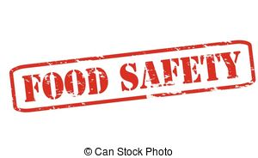
IMPORTANT THINGS TO REMEMBER WHEN USING OFFER VS. SERVE DURING COVID-19

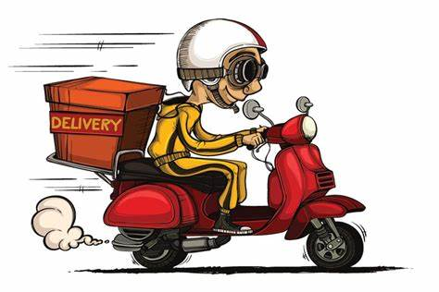

- Food items/components would need to be declined BEFORE the student receives it.

- Once the Student has taken the food the chance to
decline is gone.

